**Data Warehouse Design and Implementation**

**Database**: AdventureWorks_PurchasingDW

Designed a dimensional model for the purchasing schema of the database AdventureWorks2014 and displayed its model below

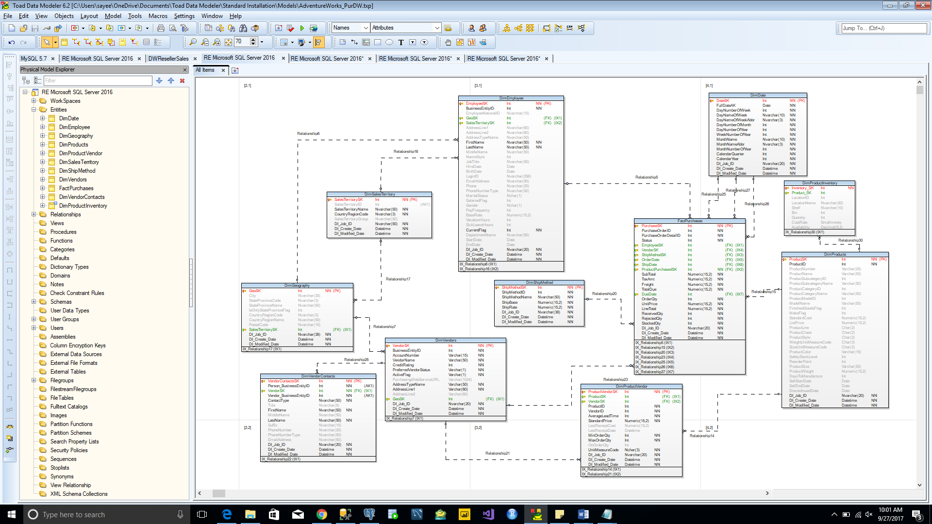

The DDL script is generated and implemented the AdventureWorks_PurchasingDW in MS SQL server and displayed below

